Lerato Orphanage: Digital Transformation

Table of Contents
Group 1 Participants: 2
Entities: 3
1. Background Paragraph 8
2. Problem Statement 9
3. Constraints 10
4. Scope Definition 11
5. Goals of the project 12
6. Opportunities to improve 13


Group 1 Participants:
Nyengedzo Jonathan Cherane
Database Manager/Group Leader,
45683638

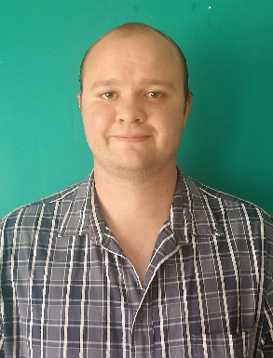
Marthinus von Holtzhausen,
Database Administrator,
45628467

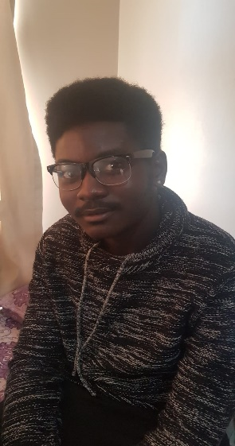
Tanyi Samuel Mthuli,
Lead Database Designer,
45672202


Muvhuya Shanel Kwinda,
Database Designer (Support),
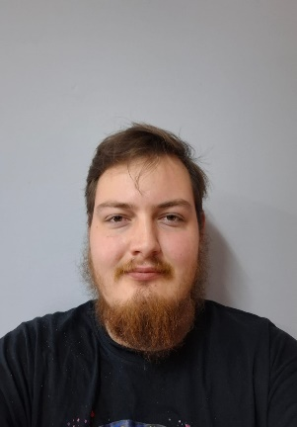
42651530

Neo Von Benecke,
Database Analyst,
40898253

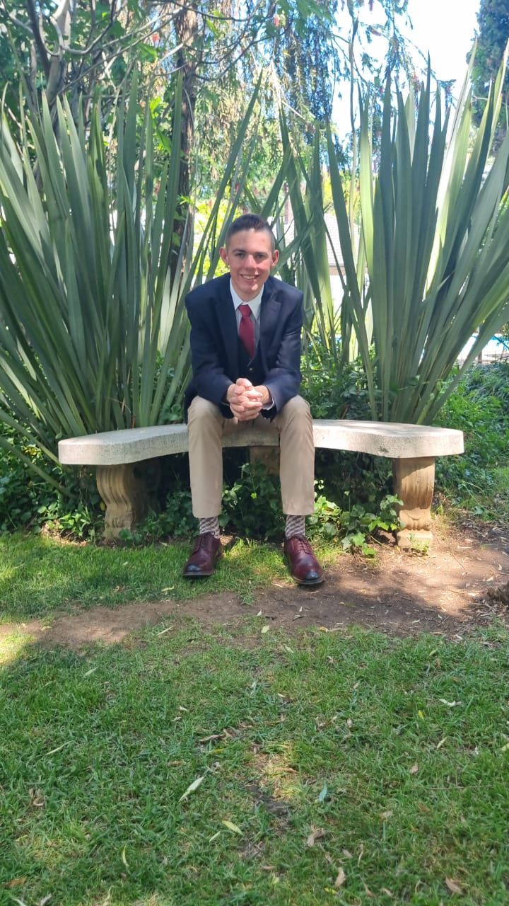
Henko van Greunen,
Database Builder
50258796

Entities:
- Employees
  - Employee ID
  - Full Name
  - Position/Role
  - Salary
  - Date of Hire
  - Employment Status (Full-time/Part-time)

- Foster Parents
  - Full Name
  - Location
  - Age
  - Number of Children Fostered
  - Licenses/Documents

- Adoptive Parents
  - Full Name
  - Age
  - Adoption Status (Completed/In Process)
  - Adoption Type (Domestic/International)
  - Adopted Children (Count/First-time)

- Children
  - Full Name
  - Age
  - Date of Birth
  - Date of Admission
  - Medical Details

- Biological Parents
  - Full Name
  - Age
  - Marital Status
  - Health Status
  - Contact Info

- Volunteers
  - Volunteer ID
  - Full Name
  - Skills/Expertise
  - Availability Schedule
  - Assigned Tasks

- Donors
  - Donor ID
  - Full Name/Organization
  - Contact Info
  - Donation Type (Cash/Material/Services)
  - Donation History

- Sponsors
  - Sponsor ID
  - Organization Name
  - Contact Person
  - Sponsorship Type (Education, Healthcare, Infrastructure)
  - Duration of Sponsorship

- Healthcare Providers
  - Provider ID
  - Full Name
  - Specialty (Doctor, Nurse, Therapist)
  - Contact Info
  - Assigned Children

- Teachers/Tutors
- Teacher ID
- Full Name
- Subject Expertise
- Schedule
- Assigned Children

- Counsellors/Psychologists
- Counsellor ID
- Full Name
- Certification/License
- Contact Info
- Assigned Cases

- Vendors/Suppliers
- Vendor ID
- Company Name
- Service/Product Type
- Contact Info
- Contract Details

- Board Members
- Member ID
- Full Name
- Role (Chairperson, Treasurer, etc.)
- Term Duration
- Contact Info

- Government/Regulatory Authorities
- Authority ID
- Department Name
- Contact Person
- Compliance Requirements
- Inspection Dates

- Alumni (Former Children)
- Alumni ID
- Full Name
- Age
- Current Status (Education/Employment)
- Contact Info

- Events
- Event ID
- Event Name
- Date
- Purpose (Fundraising, Awareness, Celebration)
- Participants

- Training Programs
- Program ID
- Program Name
- Duration
- Target Audience (Employees, Volunteers, Parents)
- Certification Status

- Financial Records
- Record ID
- Transaction Type (Income/Expense)
- Amount
- Date
- Source/Purpose

Background Paragraph
Lerato Orphanage is a non-profit organisation in South Africa that strives to provide a safe, loving, and nurturing environment for children in foster or adoptive care. Besides their small staff, the orphanage depends on volunteers, donors, sponsors, medical professionals, educators, and counsellors to look after the needs of the children. They also have the details of the biological parents in case they ever want to be reunited, while also keeping track of the children who have been to the orphanage to celebrate their achievements. Sellers and suppliers support the orphanage's day-to-day operations, while board members oversee management and relationships with the government. Events and programmes help build relationships with the community and develop the skills of staff, while financial records help with being open and sustainable. Parents who want to adopt locally or from abroad are more than welcome, although with international adoptions, it takes longer legally. This network of stakeholders is a testament to the orphanage's commitment to care, being accountable, and empowering the communities they serve.

Problem Statement
The orphanage has many challenges because it lacks an organized way to keep track of all its different types of stakeholders. These are now employees, foster parents, adoptive parents, biological parents, children, volunteers, donors, sponsors, healthcare providers, teachers, counsellors, vendors, board members, governing agencies, former residents, events, training sessions, and financial reports.
Currently, all records, such as employee pay, medical records of children, donor records of gifts, and compliance data, are stored in a hands-on, paper-based process. This method has created a multitude of problems:
- Inefficient: All manual processes take a significant amount of time to access and update records.
- Inaccurate: Without automated procedures for verification, errors are likely to occur.
- Data Security: Paper records can be lost, stolen, or damaged, and put highly confidential information at risk.
- Poor Communication: Lack of a central place to store records impedes timely cooperation between workers, volunteers, and visitors.
- Noncompliance Risk: Difficult to keep track of frequently changing regulations concerning government inspections, licenses, and sponsorship agreements, which greatly increases the risk of being out of compliance.
- Limited Reporting: Also, no on-demand report generation is available, which makes it difficult to assist staff in measures of effectiveness, provide donors with open and transparent use of their donated funds, and for decision-making.
These issues greatly impact the productivity and success of the orphanage as well as the orphanage’s ability to protect sensitive information across its increased network of stakeholders.

Constraints
- Development Costs: Budget of R250,000 (development only).
- Hardware: A dedicated server, staff PC's, and backup devices will be required, but will not be covered under the budget.
- Software: Visual Studio and MySQL Licensing will need to be acquired and maintained separately.
- Infrastructure: Hosting and maintenance costs for the MySQL server need to be budgeted for.

Scope Definition
The Lerato Orphanage's record-keeping project consists of designing and implementing a digital system to manage the orphanage's records. To complete this, a system will be developed with Visual Studio and a MySQL database. The goal is to create a record management system that increases efficiency, accuracy, and allows for better oversight for all 18 entities associated with the orphanage.
There are several key components of the project:
- Record Management: The system will provide comprehensive record management capabilities for children, employees, foster/adoptive parents, biological parents, volunteers, donors, sponsors, health care providers, teachers, counsellors, vendors, board members, alumni, events, training programs, and financial records.
- Data Security: A strong security infrastructure, including encryption and two-factor authentication, will be implemented to protect sensitive personal, medical, and financial data.
- Efficiency of Access and Updates: Staff will have the ability to quickly access and update records, so there is no need to rely on paper forms.
- Compliance: Records will be kept to ensure that the orphanage is meeting all licensing, regulatory, and inspection requirements.
- Reports and Analytics: Reports will be generated in real-time regarding children’s welfare, employee performance, donor contributions, financial transactions, and the outcomes of events.
- Collaboration: A consistent user interface will be provided for managing schedules and updating the status of projects between all stakeholders.
- User-friendly: The system will be designed so that staff, volunteers, and administrators can easily use the system.

Goals of the project
To achieve successful implementation of the new software and system, the following outcomes are required:
- Fully Automate All 18 Records: Create a streamlined process for adding, modifying, and deleting records across all 18 records via the proposed software.
- Consistent Communication Across All Users: Provide all users with the same user interface (UI) for scheduling, updating, coordinating, and interacting with each other regarding scheduling, updating, coordinating, and interacting with providers of health care and donors/sponsors.
- Improve Collaboration: Enable multiple users (staff, volunteers, and board members) to access and modify records simultaneously to enhance collaborative efforts and provide better teamwork and coordination.
- Secure Personal Information: Use encryption, role-based accessibility controls, and two-factor authentication to protect sensitive personal, medical, and financial records.
- Ensure Compliance: Keep accurate records of licensing, inspections, and all governmentally mandated requirements that must be followed to be compliant with laws and regulations.
- Provide Transparency & Accountability: Maintain accurate historical records of all donations, sponsorships, and financial transactions to ensure the trust of your stakeholders.
- Provide Holistic Support for the Child: Connect educational, medical, and psychological data to provide the best possible care for each child.
- Move to Paperless Operation: Eliminate the need for physical documentation to reduce the chance for loss/drain on productivity.

Opportunities to improve
The following suggestions will improve the operations of the orphanage:
- Backup and Recovery of Data: Create a backup and a disaster recovery plan for each entity to guarantee the safety of the records.
- Advanced Security: Introduce both two-factor authentication and role-based access, along with audit trails for securing sensitive data.
- Integrated Communication Tools: Create communications systems that can be used for messaging and scheduling among the staff, the volunteers, health care professionals, and adoptive/ foster parents.
- Analytics and Reporting: Provide dashboards and reports on child welfare, donor contributions, financial health, and outcomes of events to allow for more informed decision-making.
- Engagement of Stakeholders: Monitor alumni progress, donor history, and sponsor commitments to expand relationships over the long term.
- Training and Development: Document training programs for employees, volunteer workers, and foster/adoptive parents to ensure ongoing continuous improvement.
- Management of Events: Manage all fundraising, awareness, and community events through digital means, including participant tracking and reporting of outcomes.
- Scalability and Growth: Build the system to have the ability to scale as the orphanage grows, providing the ability to accommodate many more children, parents, and stakeholders with no negative performance issues.

Schedule of the project
- Scope Definition - 03/06/26
- Problem Analysis - 03/06/26
- Requirement Analysis - Collect user requirements from staff, foster/adoptive parents, volunteers, donors, and government authorities.
- Logical Design - Develop entity relationship models for all 18 entities.
- Decision Analysis - Conduct a feasibility study (budget, infrastructure, and staffing).
- System Development - Code in Visual Studio with MySQL database integration.
- Testing & Quality Assurance - Validate security, reporting, and compliance features.
- Training & Deployment - Train staff, volunteers, and administrators on how to use the system.
- Monitoring & Evaluation - Continuous improvement through feedback loops and reporting.

Budget
- The project has a limited budget of R250,000. There are additional costs to take into consideration, including:
- Hardware for Implementation: Dedicated server hardware; staff computer hardware; backup storage devices.
- Software Licenses: Visual Studio; hosting for MySQL server; security tools.
- Development Costs: Programmers’ salaries; testing; integration of the new system.
- Staff Training Costs: Workshop training for staff, volunteers, and foster/adoptive parents.
- Ongoing technical support for the production system, system updates, and backup maintenance/repair.
- Contingency Fund: Approximately 10% of the total budget should be held for unexpected expenses.

Internal Resources
To have a successful outcome, the following internal resources will be utilized:
- Employees - These are the main group of people who will operate the system and perform daily operational tasks.
- Volunteers - They will assist with inputting data, providing training, and serving as support for things like special events.
- Board Members - They provide governance, oversight, and decision-making.
- Information Technology Department - This includes the software developers, database administrators, and system testers.
- Healthcare Providers & Counsellors - They will provide input on medical and psychological records.
- Teachers/Tutors - They will provide updated educational progress reports.
- Donors/Sponsors - They will provide financial support and materials to facilitate the infrastructure.
- Government - They will provide legal and regulatory compliance.
- Alumni Network - They will provide feedback and support for community involvement.

